C PROGRAMMING TO INTIALIZE THE ARRAY DYNAMICALLY AND PRINT THE ARRAY

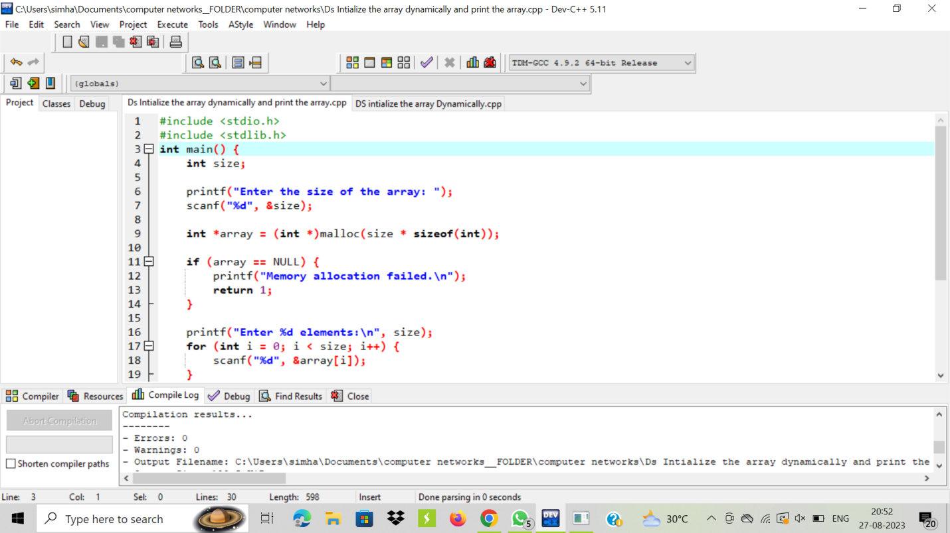

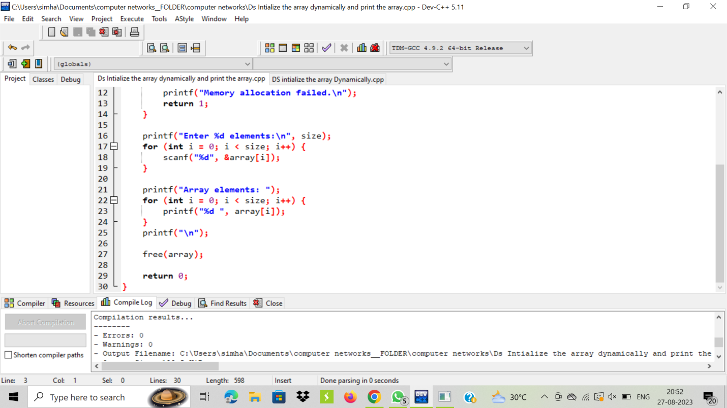

OUTPUT:

